[2018 Fall] Application form - SKKU Graduate school
2018학년도 후기 외국인특별전형 (※: This symbol means ‘Official Only’) |  |  |  |  |  |  |  |  |  |  | 수험번호(Applicant No.) |  |  |  |  | ※
성명(Name) |  |  | Korean |  |  |  |  |  |  |  |  |  |  |  |  |  |  |  | 사 진  (Photo)  (4Cm×5Cm)
 |  |  | English | (Surname) |  |  |  |  | (Given names)
지원학과 (Major that applicant  wants to study at SKKU) |  |  |  | (the exact name on the guide)
과정 (Master’s/Doctorate /Master’s&Doctorate)
입학구분 (First Year or Transfer)
생년월일 (Date of birth) |  |  |  | (Day) |  |  | (Month) |  |  |  |  | (Year)
국적 (Nationality)
공인어학능력시험 점수 - TOPIK  (Official Language Test Results) |  |  |  |  | 공인어학능력시험 점수 – English  (Official Language Test Results) |  |  |  |  |  |  |  | (Test) |  |  |  |  |  |  |  | (Score)
여권번호 (Passport NO.) |  |  |  |  |  |  |  |  |  | 외국인등록번호(Alien Registration NO.)  (Card Holders Only)
이메일 (E-mail) |  |  |  |  |  |  |  |  |  | 휴대폰번호(Cellular phone NO.)
성균관대내의 추천교수 성명 및 연락처
Recommending SKKU professor(if any)’s name, phone number, email address
※자연과학, 공학 계열 지원자는 지원 전 지도교수를 선정하여 미리 연락하시길 바랍니다.
Applicants for the department of Natural Science and Engineering are recommended to select his/her adviser and contact the professor prior to applying
학  력 | 학 사 (Bachelor) |  |  | Name of University  (Official English Name)
 |  |  |  | Major |  |  |  |  |  |  |  |  | Grade Point Average  (GPA) |  |  |  |  |  |  | (out of)  /
 |  |  |  | Date of admission |  | (Day/Month/Year) |  |  |  |  |  |  | Date of graduation |  |  |  |  |  |  | (Day/Month/Year)
 | 석 사 (Master’s) |  |  | Name of University  (Official English Name)
 |  |  |  | Major |  |  |  |  |  |  |  |  | Grade Point Average  (GPA) |  |  |  |  |  |  | (out of)  /
 |  |  |  | Date of admission |  | (Day/Month/Year) |  |  |  |  |  |  | Date of graduation |  |  |  |  |  |  | (Day/Month/Year)
 | 박 사 (Doctorate) |  |  | Name of University  (Official English Name)
 |  |  |  | Major |  |  |  |  |  |  |  |  | Grade Point Average  (GPA) |  |  |  |  |  |  | (out of)  /
 |  |  |  | Date of admission |  | (Day/Month/Year) |  |  |  |  |  |  | Date of graduation |  |  |  |  |  |  | (Day/Month/Year)
父 국적 (Nationality of father) |  |  |  |  |  | 母 국적 (Nationality of mother)
Official Only | 1.자기소개서 Self-Introduction |  |  | ※ |  | 7.학력조회동의서 Letter of Consent |  |  |  |  |  |  |  |  | ※ |  |  |  |  |  |  | 수입증지※
 | 2.학업계획서 Study Plan |  |  | ※ |  | 8.학력조회의뢰서 Letter of Request |  |  |  |  |  |  |  |  | ※
 | 3.학사 졸업(예정)증명서  Certificate of graduation(Bachelor) |  |  | ※ |  | 9.고등교육학력사순보고서  Credential Reports(Institutions in China only) |  |  |  |  |  |  |  |  | ※
 | 4.학사 성적증명서  Transcript(Bachelor) |  |  | ※ |  | 10.어학능력증명서(한국어/영어)  Language Certificate |  |  |  |  |  |  |  |  | ※
 | 5.석사 졸업(예정)증명서  Certificate of graduation(Master) |  |  | ※ |  | 11.가족관계증명서  Family relations certificate |  |  |  |  |  |  |  |  | ※
 | 6.석사 성적 증명서  Transcript(Master) |  |  | ※ |  | 12.여권컬러사본 Color copy of passport |  |  |  |  |  |  |  |  | ※
서류제출일 |  | ※ |  |  |  |  |  | 전산입력일 |  |  |  |  |  | ※
Self-Introduction
자 기 소 개 서(한글or영문)
2018-Fall
지원학과  Major |  | 성 명  Name

SUNGKYUNKWAN UNIVERSITY GRADUATE SCHOOL

Study Plan
학업계획서
2018-Fall
Type of Application  구 분 | First Year( ) Transfer( )  신입학 편입학 | Degree  과 정 | Master’s( ) Doctorate( ) Master’s & Doctorate( )  석사 박사 석박사통합
Major  지원학과 |  | Name  성 명
※ Describe your study plan according to headings below.(1page each, in Korean or English)
입학후의 학업에 대한 계획을 다음 항목별로 기술하십시오.(각 1매)(한글 또는 영어로 작성하시오)

1. Personal academic orientation  3. Future study plan(s) |  | 2. Reason of application and personal goal(s)  4. Other(s)

SUNGKYUNKWAN UNIVERSITY GRADUATE SCHOOL

Study Plan
학업계획서
2018-Fall

SUNGKYUNKWAN UNIVERSITY GRADUATE SCHOOL

Study Plan
학업계획서
2018-Fall

SUNGKYUNKWAN UNIVERSITY GRADUATE SCHOOL

2018-Fall
CONSENT FORM OF ACADEMIC INQUIRY (학력조회동의서)
NO

SUNGKYUNKWAN UNIVERSITY
Office of International Student Services
2066, Seobu-ro, Jangan-gu, Suwon, Korea

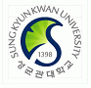

Tel: +82-31-290-5028
Fax: +82-31-290-5239
http://www.skku.edu

※Applicants should fill in the blanks marked with ♣ in English only

To whom it may concern:
This letter is to confirm that I attended ( ^{♣Name of your graduated school} ).
I have applied to Sungkyunkwan University in Seoul, Korea for the ♣2018 academic year and have agreed to allow Sungkyunkwan University to officially request my academic records from the school I graduated from.

In this regard, I would like to request your full assistance when the University Admission Office contacts you regarding verification of enrollment and transcripts.

Enrolled Name: ♣

Student ID Number: ♣
Date of birth: ♣

Date of admission (transfer): ♣
Date of graduation (withdrawal): ♣
(♣Information at the graduated school)

Sincerely yours,

♣_____________________ ^{♣(월)} - ^{(일)} - ^{(년)}2017
Signature Date

※일자 표기(Example)

11 - - 2017
(월:Month) (일:Day) (년:Year)

2018-Fall
LETTER OF REQUEST FOR ACADEMIC INQUIRY(학력조회의뢰서)
NO

SUNGKYUNKWAN UNIVERSITY
Office of International Student Services
2066, Seobu-ro, Jangan-gu, Suwon, Korea

Tel: +82-31-290-5028
Fax: +82-31-290-5239
http://www.skku.edu

※Applicants should fill in the blanks marked with ♣ in English only

♣Date: . . . (dd/mm/yyyy)
♣School Name:
♣ School Address:
♣Zip code: ♣ School Tel:
♣Fax: ♣ School or staff E-mail:
♣Student Name: ♣ Student ID Number:

Subject: Requesting Student Information
Dear Sir or Madam,
The above applicant has submitted educational documents issued by your institution to our university. We ask you to verify the accuracy and authenticity of the enclosed documents. We need your confirmation about his/her graduation, major field, and the date of Graduation. Please complete below and return this document to our office. You can respond via fax or mail.
Thank you for your cooperation. We look forward to hearing from you soon.

Sincerely,

Vice President of International Affairs ※
Questions to verify student information

Student’s name: ※

Degree: ※

Major: ※

Date conferred: ※

Name of institution: ※

Signature of University Official ※
영어 능력 확인서
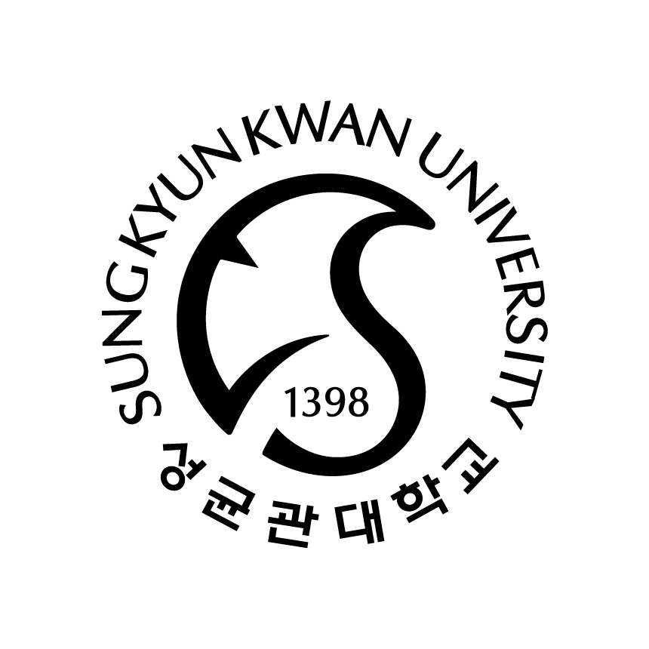
Certificate of English Proficiency
성 명(Name) :
생년월일(Date of Birth) :
수험번호(Application No.) :
지원학과(Major) :
학위과정(Degree) :

우리 학과는 대학원과정 수업의 대부분이 영어로 진행되고, 학위 논문을 영어로 작성할 수 있습니다.
위 지원자가 우리 학과 전공 수업을 영어로 수강하고, 학위 논문을 영어로 작성하기 위해 필요한 영어 능력을 충분히 갖추었다고 판단합니다.
The graduate school of our department offers most of its courses in English, and the graduation thesis can also be written in English.
I hereby confirm that the above applicant has sufficient English proficiency to take our department’s English courses and write graduation thesis in English.

201 . . .

지도교수 (인) 학과장 (인)
Adviser (Signature) Chair of Dept. (Signature)

Department
at Sungkyunkwan University
Recommendation Form – CICE Graduate School
서식 7 : 전자전기컴퓨터공학과 지도교수 추천서※ 전자전기컴퓨터공학과 지원자만 작성 (Just for the Applicants to Electrical&Computer Engineering Department)
2018 Fall
지원자  (Applicant) | 성명 (Name) |  |  | 생년원일  (Date of Birth)
 | 국적 (Nationality) |  |  | 연락처  (Contact No.)  *Email, Phone No.
 | 지원학과  (Prospective Major) | Electrical and Computer Engineering |  | 학위 과정  (Degree)  *Please Check ✓ |  | 석사(Master’s) |  | ( )
 |  |  |  |  |  | 박사(Doctorate) |  | ( )
수험번호
(Applicant No.)
 |  |  |  |  |  | 석박tk통합(Combined Master’s & Doctorate) |  | ( )
추천교수  (Recommender) | 추천교수 정보  (Information of Professor) | 성명  (Name) |  |  | 연락처  (Contact No.)
 |  | 소속 대학  (College) |  |  | 소속 학과  (Department)
 | 추천내용  (Recommendation) | Please state the level of your recommendation in Korean or English.
본인은 위 학생을 2018학년도 후기 신입학 일반대학원 전형에 추천하고자 합니다.
I hereby recommend the applicant aforementioned for admission to the 2018 Fall Semester in the General Graduate School.
201 . . .

Professor: (Signature)
The Chair of Department of Electrical and Computer Engineering
Recommendation Form-The College of Software Graduate School
서식 8 : 소프트웨어플랫폼학과 지도교수 추천서※ 소프트웨어플랫폼학과 지원자만 작성(Just for the Applicants to Platform Software Department)
2018 Fall
지원자  (Applicant) | 성명 (Name) |  |  | 생년원일  (Date of Birth)
 | 국적 (Nationality) |  |  | 연락처  (Contact No.)  *Email, Phone No.
 | 지원학과  (Prospective Major) | Software Platform |  | 학위 과정  (Degree)  *Please Check ✓ |  | 석사(Master’s) |  | ( )
 |  |  |  |  |  | 박사(Doctorate) |  | ( )
수험번호
(Applicant No.)
 |  |  |  |  |  | 석박사통합(Combined Master’s & Doctorate) |  | ( )
추천교수  (Recommender) | 추천교수 정보  (Information of Professor) | 성명  (Name) |  |  | 연락처  (Contact No.)
 |  | 소속 대학  (College) |  |  | 소속 학과  (Department)
 | 추천내용  (Recommendation) | Please state the level of your recommendation in Korean or English.

본인은 위 학생을 2018학년도 후기 신입학 일반대학원 전형에 추천하고자 합니다.
I hereby recommend the applicant aforementioned for admission to the 2018 Fall Semester in the General Graduate School.
201 . . .
Professor: (Signature)
The Chair of Department of Platform Software
Recommendation Form
서식 9 : 에너지시스템공학협동과정 지도교수 추천서※ 에너지시스템공학협동과정 지원자만 작성(Just for the Applicants to Interdisciplinary Program in Energy Systems Engineering)
Interdisciplinary Program in Energy System Engineering
2018 Fall
지원자  (Applicant) | 성명 (Name) |  |  | 생년원일  (Date of Birth)
 | 국적 (Nationality) |  |  | 연락처  (Contact No.)  *Email, Phone No.
 | 지원학과  (Prospective Major) | Software Platform |  | 학위 과정  (Degree)  *Please Check ✓ |  | 석사(Master’s) |  | ( )
 |  |  |  |  |  | 박사(Doctorate) |  | ( )
수험번호
(Applicant No.)
 |  |  |  |  |  | 석박사통합(Combined Master’s & Doctorate) |  | ( )
추천교수  (Recommender) | 추천교수 정보  (Information of Professor) | 성명  (Name) |  |  | 연락처  (Contact No.)
 |  | 소속 대학  (College) |  |  | 소속 학과  (Department)
 | 추천내용  (Recommendation) | Please state the level of your recommendation in Korean or English.
본인은 위 학생을 2018학년도 후기 신입학 일반대학원 전형에 추천하고자 합니다.
I hereby recommend the applicant aforementioned for admission to the 2018 Fall Semester in the General Graduate School.

201 . . .
Professor: (Signature)
The Chair of Interdisciplinary Program in Energy Systems Engineering

